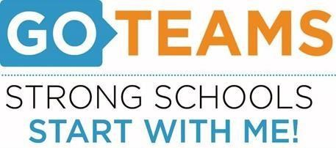
School | Date | Time | Location
BEST Academy (6-12) | 1/13/22 | 5:00pm | Zoom Call
Notice Prepared By: Dr. Timothy Jones Date Posted: January 10, 2022 Revised: 1/9/22

Meeting Agenda
(Agenda may be amended)
This meeting will allow for Public Comment
Join Zoom Meeting: https://atlantapublicschools-us.zoom.us/j/82681561524?pwd=WVh1TlViejE1aHhtNC8xU0NjR2R3Zz09
- Call to Order
- Roll Call; Establish Quorum
- Action Items
  - Approval of Agenda
  - Approval of Previous Meeting Minutes
C. Budget Update
- Strategic Plan Review
- Discussion Items
- Budget Workshop Viewing
- Budget Review
- Review Strategic Plan
- Information Items
A. Test Talk (Dr. Johnson and Ms. Kelley)
B. Anti-Gun Violence Initiative – Dr. Jones
C. TEM Update

- Public Comments
- Announcements
- MLK Holiday (No School)
- Next Meeting Date (2/10/2022)
- Adjournment

